Two Column Proofs Notes
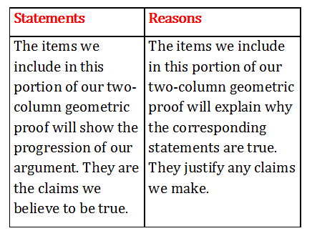

Step-by-Step Instructions for Writing Two-Column Proofs
1. Read the problem over carefully. Write down the information that is given to you because it will help you begin the problem. Also, make note of the conclusion to be proved because that is the final step of your proof. This step helps reinforce what the problem is asking you to do and gives you the first and last steps of your proof.
2. Draw a picture of the problem to help you see what is given and what you want to prove. Oftentimes, a diagram/picture has already been drawn for you, but if not, make sure you draw an accurate picture of the problem. Include marks that will help you see congruent angles, congruent segments, parallel lines, or other important details if necessary.
3. Use the information given to help you write the first steps of your proof. Every step must be shown, regardless of how obvious it appears to be. Beginning your proof with a good first step is important to arriving at a correct conclusion.
4. Use the conclusion, or argument to be proven, to help guide the statements you make. Remember to support your statements with reasons, which can include definitions, postulates, or theorems.
5. Once you have arrived at your solution, read through the two-column proof you've written to make sure that each step has a reason. This helps emphasize the clarity and effectiveness of your argument.

